**14.Securing eazybank app using oauth2 and keycloak**

Introduction to OAUTH2 flow inside EazyBank web App - section15

In the previous section, we have created a simple Spring Boot application

and try to secure it with the help of social logins like GitHub and Facebook.

But I can't use the same approach of social logins to secure my EazyBankSpringBoot web application. The reason is very simple.

Whatever auth servers that are available with the help of social logins like GitHub, Facebook, LinkedIn, Twitter, so all these auth servers, they have a very serious drawback or limitation due to which these auth servers, they can't be used inside an enterprise organization. The limitation is we will not have any control on the social login auth servers.

We can't create an role or we can't create an authority based upon our business requirements inside these auth servers. Whatever user related information

that we are getting from the social logins, we just have to accept them

and build our business logic using them. But in real applications, we can't live

with these kind of restrictions.

We may want to register thousands of end users and each of the end user may have their own authorities and roles defined inside the auth server. That's why the enterprise applications are bigger organizations, they are going to build their own auth server where they have complete control.

As a next step, we are going to enhance our EazyBankSpringBoot web application

with the OAuth 2 and by building our own auth server.

Resource Server:

So if you look at the setup that I have on this slide, first, we are going to convert our Spring Boot application into a Resource Server. So whatever Spring Boot application that we have right now, it has all the end user resources like accounts, loans, cards.

Since we want to secure all these end user resources, so the Spring Boot application server, it is going to act as a Resource Server.

client application:

And coming to the client application, I'm going to consider two types of client applications. The very first one you already know, which is Angular application.

We are going to consider this UI application as a client application inside the OAuth 2 flow.

I'm going to consider the Postman as an client application where I'm going to invoke the APIs available inside the Resource Server.

auth server using KeyCloak:

Now, coming to the auth server, we are not going to have any social login auth servers because they have so many restrictions.

we are going to build an auth server with the help of KeyCloak.

I'm going to give a good introduction about KeyCloak and we are going to set up a proper auth server with the help of KeyCloak.

In the coming sections, we're also going to build our own auth server with the help of Spring Auth Server Library.

Flow:

the client applications will reach out to the KeyCloak auth server to get an access token. When they're trying to get the access token from the auth server, they can involve end user as well if they're trying to follow the AuthorizationCode

AuthorizationCodeGrantType flow or PKCE flow. Otherwise, if they're simply following the ClientCredentialsGrantType flow, they don't have to involve any end user.

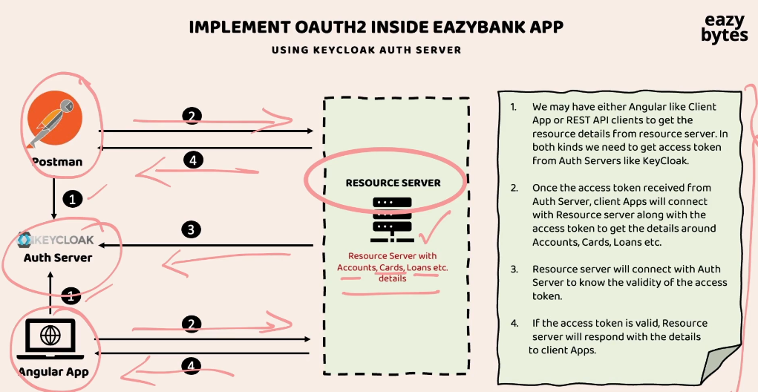

So once the access token is received from the auth server, these client applications,

they're going to send the access token to the Resource Server as part of the request 2. Once the access token is received by my Resource Server, the Resource Server, it is going to validate if the access token is valid or not in the step three.

So this validation, it is going to perform by connecting with the auth server, which is KeyCloak in our scenario. If the provided access token is valid, at last, my Resource Server is going to respond with the secured resources as part of the step four.

So as part of the step four, the client applications, they're going to receive the response from the Resource Server.

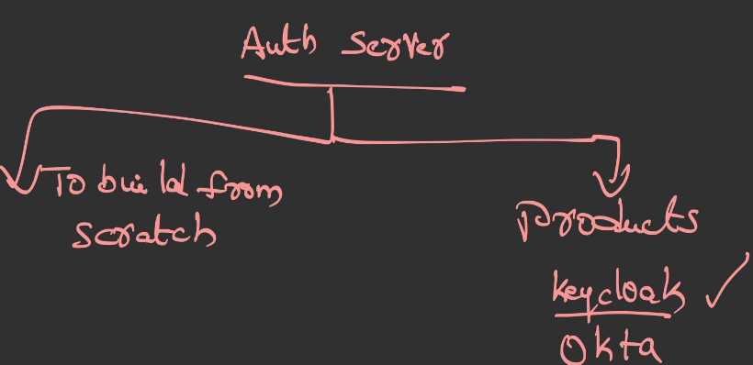

So whenever an organization is looking to build an auth server, they will have two options. The very first option is so to build from scratch.

The other option is they can leverage the products that are supporting the OAuth 2 and Open ID standards. So these products are like KeyCloak, which is an open source product, and similarly we have Okta. All the cloud providers like AWS, Azure, GCP, they also have products around the OAuth 2 and OpenID Connect.

But inside this course I'm going to use KeyCloak, which is the open source product.

Here you may have a question, which is "How organizations are going to choose

one of these option?" It all depends upon the organization requirements.

If an organization has huge manpower and budget and time, then they can build their own auth server from scratch by using libraries like Spring Auth Server.

Otherwise, they're going to adopt the readily available products like KeyCloak and Okta.

We're going to explore both of these two options inside this course.

First, with the help of KeyCloak, I'm going to show you the OAuth 2 flow

inside the EazyBank application.

In the coming sections, I'm also going to show you how to build our own auth server

with the help of the Spring Auth Server Library.

Introduction to KeyCloak Auth Server

Instructor: When we are talking about OAUTH 2 and OpenID framework for the very first time, I told you that OAUTH2 or OpenID, They are just standards or specifications. They're not actually a proper product, which can be leveraged by any organization.

That's why they are simply guidelines of standards, or specifications.

Based upon these OAUTH 2 standards or specifications or guidelines.

Bigger organizations like Facebook, GitHub, LinkedIn, Google, Netflix, Amazon,

they started building their own Auth server for their own internal purpose.

The most famous products:

The very first product I would recommend anyone to use is Keycloak,

because this is an open source product which is built and maintained by the Cloud Native Computing Foundation. Similarly, we also have some commercial products like Okta.

Okta is very famous commercial product. Any organization who are ready to pay few hundreds or few thousands of dollars, they can happily adopt these Okta.

We also have other product with the name AuthO. This AuthO product is recently acquired by Okta itself. That's why you are able to see here AuthO by Okta,

this is also one of the famous readily available

Auth servers that organizations can leverage. At last, we also have Amazon Cognito from the AWS. If your organization is using AWS component to a great extent,

then using these product will be a good decision, because it has a good integration with the AWS components.

Even if someone is not using AWS, they can still use this product.

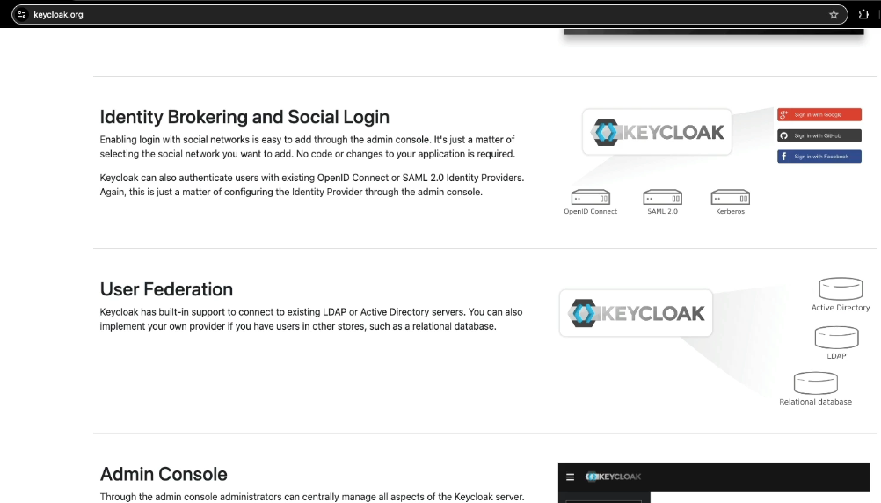

But inside this course, I'm going to use Keycloak. The reason is very simple.

It is an open source. With the help of this Keycloak, we should be able

to set up the Auth server inside our local, development and production system.

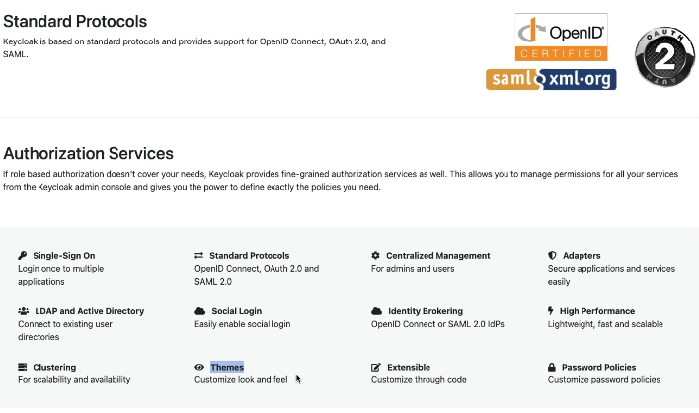

So if you try to understand what is there inside this website, the very first highlighted information here is, it is an open source identity and access management product.

It is going to support **single sign-on, Identity Brokering and Social Login.**

**User Federation. User Federation** means we can store all the user credentials

inside storage systems like relational database, LDAP, active directory, and we can point our Keycloak to these storage systems so that the Keycloak can perform the authentication and authorization based upon these configured storage systems.

And similarly, this product is also going to provide you admin console

where admins can set up some configurations related to the Auth servers.

It is also going to provide you Account Management console for normal users.

Next, here we have the most important information, which is it is going to support the standard protocols like Open ID Connect, OAuth 2.

And it is also going to support various authorization services. With the help of these Keycloak Auth server, we should be able to set up a cluster to handle any kind of traffic. If needed, we can also customize the login page of the Auth server based upon our own organization look and feel requirements.

But to get started with these Keycloak server first, we need to set up these inside our local system. Let's try to set up this Keycloak server.

Installation of KeyCloak server, setup admin account & realm

Let's try to set up Keycloak inside our local system.

To know the installation steps, we need to click on this Get Started.

Inside these guides page you'll be having lot of information on how to set up Keycloak. You as a developer, you are not responsible to set up these Keycloak server.

Either your DevOps team or platform team or deployment team, they're going to set up this Keycloak inside various environments and they're going to provide the URLs to the developers.

Using these URLs developers, they can start implementing the OAuth 2.0

inside their web applications.

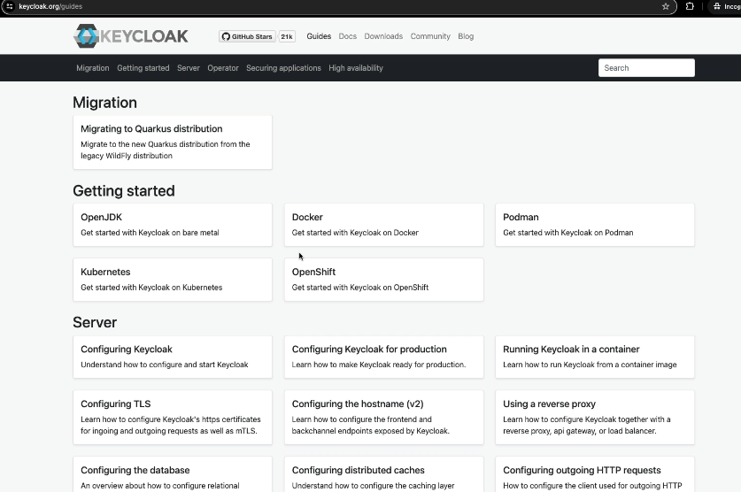

Docker setup:

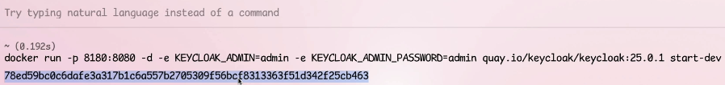

At the end of the command, we also have an option which is start-dev.

With this, we are telling to the Keycloak to start using a development profile or development mode. So whenever we start Keycloak using a development mode,

what is going to happen is it is going to have an embedded H2 database or in-memory database to store all the end user details and all other configurations that we are going to make.

So we should be fine with these in-memory database, but in real projects, your Keycloak admin, they're going to set up a proper storage system like MySQL database or LDAP or Active Directory based upon your organization requirements.

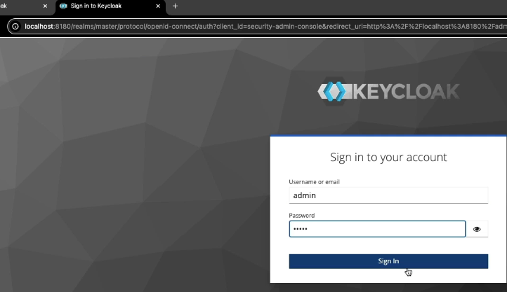

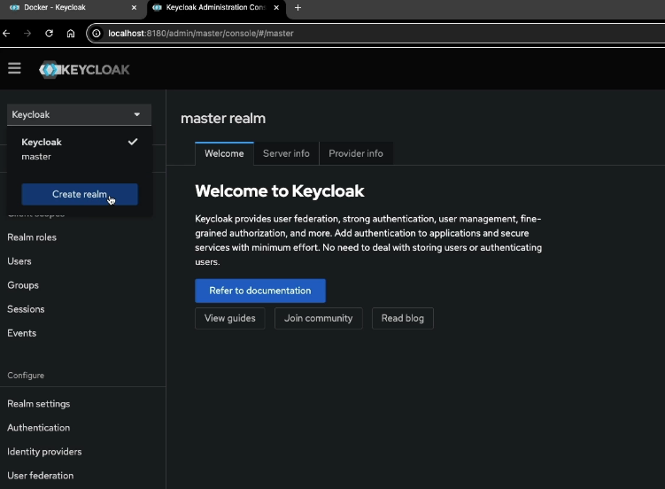

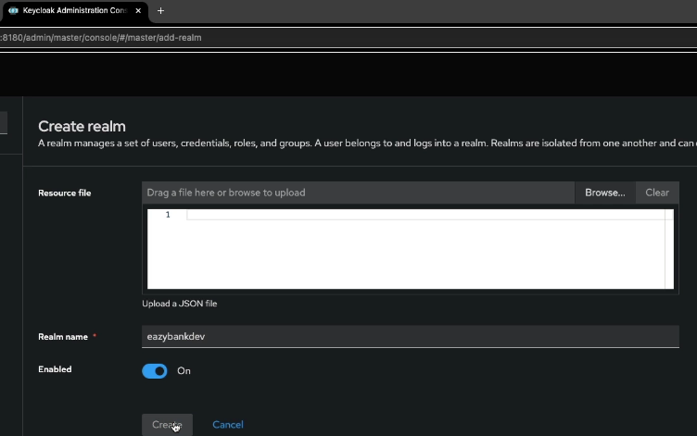

what is a realm?

You have details here. A realm is a space which is going to manage a set of users,

credentials, roles, and groups. This is very similar to the environments.

For example, if your organization have environments like dev, QA, production,

there is a very good chance we are not going to maintain the same users,

same credentials across multiple environments.

To support these kind of requirements or scenarios, every auth server that is built on top of OAuth 2.0, they're going to have a concept called **realm**.

So using the realm, we are going to create a space which is going to handle a specific environment. Let me provide the realm name, which is eazybankdev.

Using this realm, I'm going to maintain all the users, clients related to the eazybank application for the development environment.

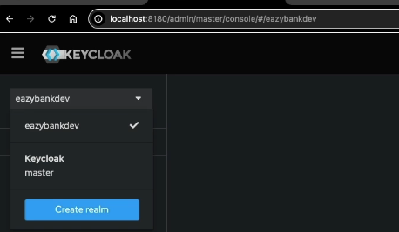

Creating Client Credentials inside KeyCloak for API-API secured invocations

For now, let's focus on persisting client details inside the Keycloak auth server.

So the details of client application that are going to vary based upon

the OAuth2 grant type flow that you are trying to set up. We discuss many grant type flows, like authorization code grant type flow, PKCE grant type flow, client credentials grant type flow, refresh token grand type flow.

We're going to explore all these grant type flows one by one. Inside this lecture, let's try to focus on how to set up a client inside auth server whenever we are looking to leverage client credentials grant type flow.

Registering client using client credentials grant type flow: api to api communication

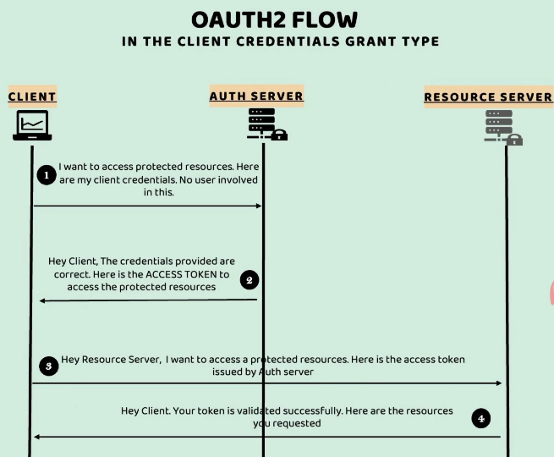 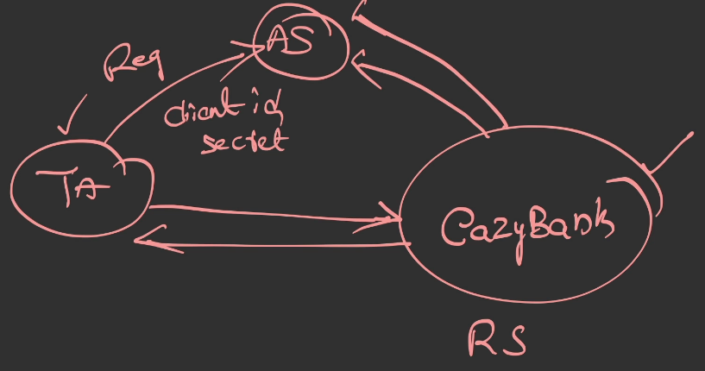

In these kind of scenarios, usually inside real projects, what is going to happen is,

whenever a third-party application or a backend application want to talk with the resource server, they're going to reach out to the leadership of this EazyBank application.

They will talk with them, they will explain the scenarios. Once proper approval is received from the leadership of the EazyBank application, the admin or the product owner of this EazyBank application, they're going to request Keycloak admin

to register the third-party application details and provide the client ID and client secret to this third-party application.

So this kind of registration process will happen behind the scenes,

and this is going to happen only once. Once the third-party application and the

client application registered with the auth server,

it can start sending requests to the EazyBank application by providing the proper access token.

Let's try to register a third-party application details inside Keycloak with the help of

Client Credentials Grant Type flow.

Login to Keycloak admin page, I'm going to enter the admin credentials.

Once we click on this sign-in button, you can see by default, the Keycloak realm is selected.

So please make sure you are selecting our eazybankdev as our realm.

Once you have selected this realm, you have an option here with the name "Clients".

You need to click on the same. By default, these are all the various clients

that are available inside the Keycloak. But since we're looking to create our own client, you need to click on this "Create client".

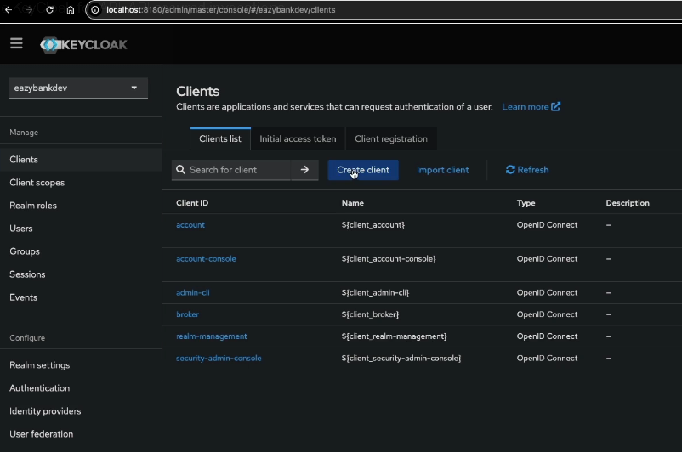

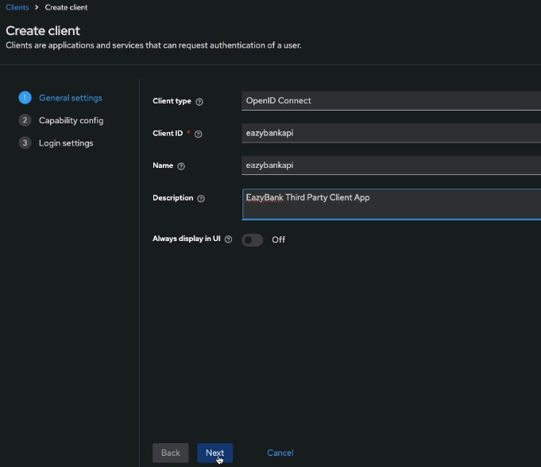 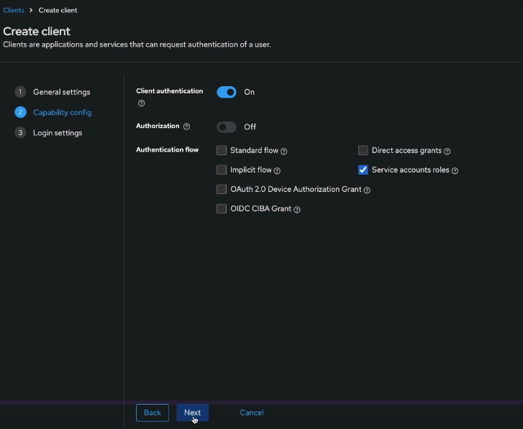

we need to enable the client authentication. Because whenever the client application

wants to get an access token from the auth server, we want the client application to prove its identity. How it's going to prove its identity? By providing the client ID and client secret. That's why to enable the authentication of client, please make sure you have enabled this option.

Next, under the authentication flow, **by default, the standard flow and the direct access grants are selected.**

So if you try to click on this question mark after the standard flow, it is going to provide more details. So standard flow refers to the Authorization Grant Type flow

in the OAuth2 specification.

Similarly, Direct access grants means Resource Owner Password Credentials Grant.

We don't want to use both these grant type flows, for the client application that we are trying to create.

**So what is the grant type flow that we are looking? We are looking Client Credentials Grant Type flow. So if you try to click on this help button after the service accounts roles, you'll be able to see that service accounts roles means Client Credentials Grant Type flow.**

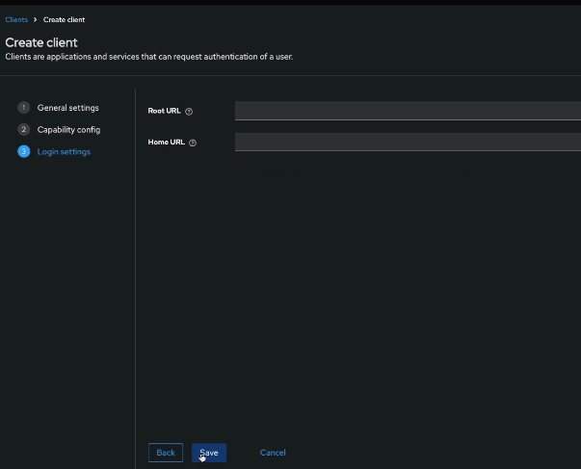 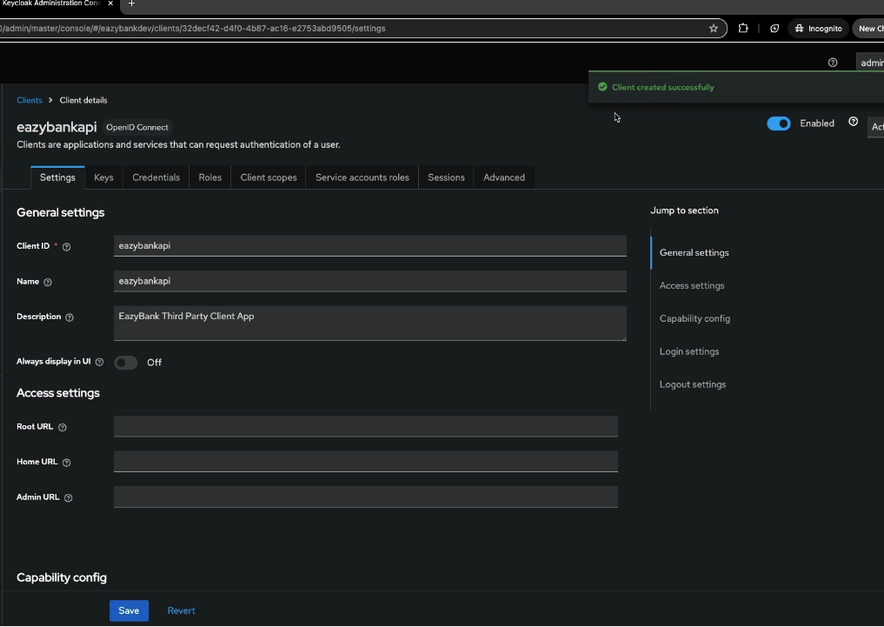

And you can ignore this root URL and home URL and click on the save button.

With this, you'll be able to see there is a message here, "Client created successfully",

and it is enabled.

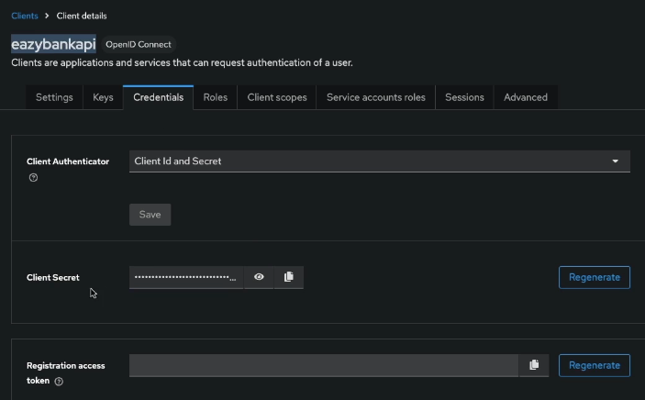

As the next step, we want to know what is the secret for this client.

So you need to click on this credentials, and here you'll be able to see the secret,

or you can also copy the secret.

So this is the client ID, which is "eazybankapi", and this is the client secret that the client has to use whenever it wants to get an access token from this Keycloak auth server.

Setup of EazyBank Resource Server - Part 1 : clone section15 from 12

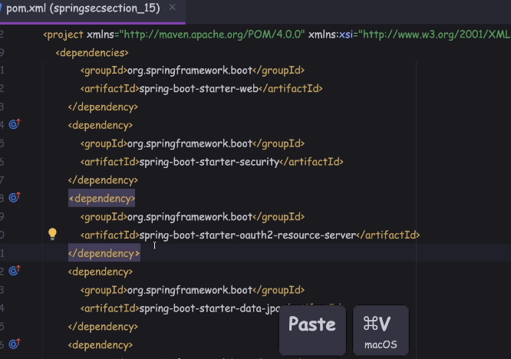

I'm going to delete all the authentication provider and user detail service related classes. So inside the authentication provider implementations, we are doing the actual authentication by loading the credentials from the storage system.

We no more want this application to perform this authentication.

We're going to give this responsibility to the key cloak auth server.

So that's why I'm going to delete all the authentication provider implementations

and the user details service implementation classes.

Next, under these configurations, as of now, we configured various filters

that are going to be responsible to generate the JWT token and validate the JWT token.

But right now, since we are going to leverage the OAuth to flow, the generation of the access tokens or the JWT tokens is going to be with the key cloak auth server.

That's why we can safely delete all the configurations and files related to the filters

that we have created so far. I'll just retain the CsrfCookieFilter.

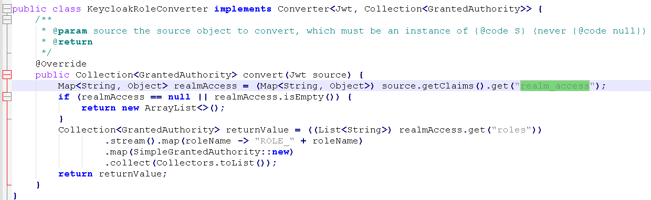

The purpose of these class is very simple. We know that right now the responsibility

of generating the Access token or JWT tokens is going to be with the key cloak.

And inside these JWT Token itself, we are going to have various information

related to the end user along with the roles details as well.

So key cloak is going to send the roles details inside the access token.

The purpose of this class is very simple. From now onwards, we know that the key cloak is going to be responsible to generate the JWT tokens or the access tokens.

Inside the Access token only, we are going to have various information about the end user or about the client application. These details include the username,

what is the email of the end user, what is the email of the client application

and what are the roles of the client application or what are the roles of the end user.

So since my access token is going to send the roles information, we need to write an converter, which is going to take the responsibility of extracting the roles information from the access token.

And once the roles information is extracted, we need to convert the roles information into the form of simple granted authority. Because Spring's security framework can only understand the roles and authorities information when we present them in the form of granted authority or simple granted authority.

Setup of EazyBank Resource Server - Part 2

delete all the formLogin() and the httpBasic() configurations.

delete these paths, invalidSession and apiLogin path details.

So with the help of this jwt method, we are telling to the resource server

that the format of the access token is going to be JWT. We know, based upon our previous discussions, there are two types of formats.

**The very first one is JWT. The other format is opaque token.**

I'll show you the demo of opaque tokens as well in the coming lectures.

For now, let's go with the JWT token format.

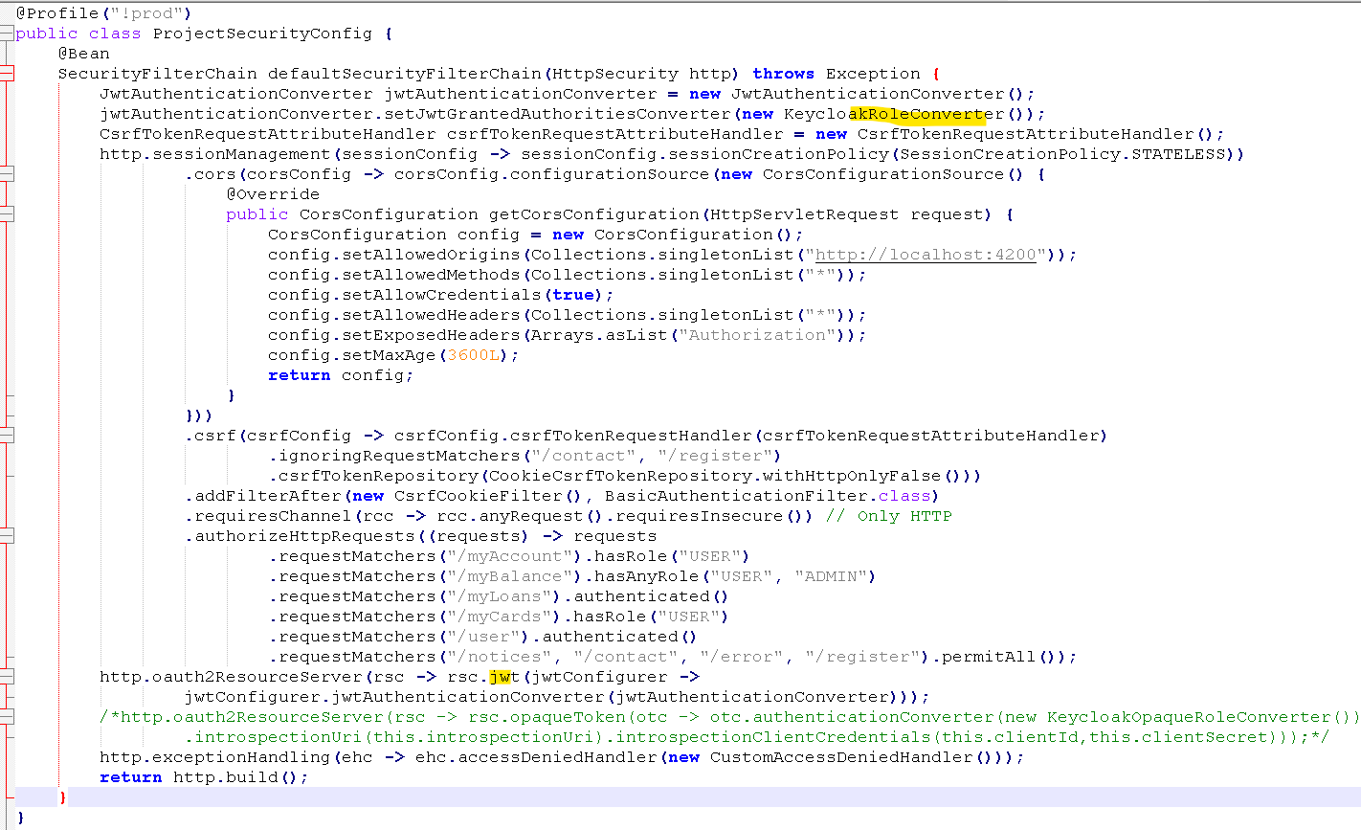

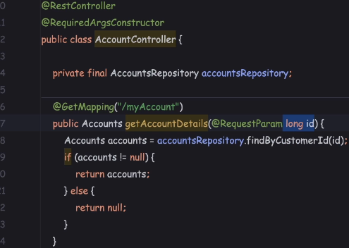 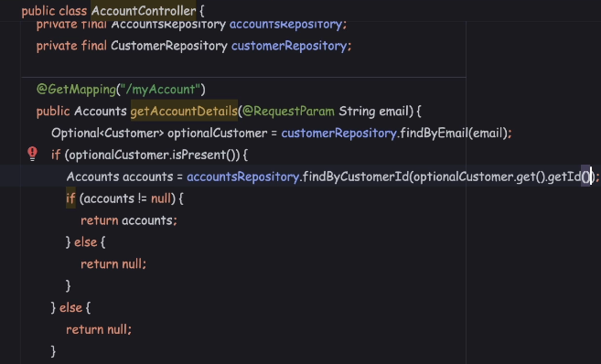

As of now, you can see the APIs inside our controllers, they are accepting the customer ID as an input. With the previous setup that we have, this type of input may work without any issues because the Angular application, first, it will try to authenticate the end user by providing username and password, and to the Angular UI application we used to send the customer details, which includes the customer ID as well. So the same customer ID value the Angular application used to send

for all the subsequent APIs.

But now since the APIs, they are going to be invoked by third-party applications,

it is not going to make sense if you ask the third-party applications

to send the customerId as an input. Because for them, customerId is not going to make any sense. This ID is specific to our database. That's why instead of id,

I'm going to change the input to the email of type String.

With the help of this email value, we need to fetch the customer details from the database.

The next change, we have to do inside the application.properties file.

So as of now, my resource server don't have any clue on how to connect with the auth server to validate the access tokens that it is going to receive from the client applications. So to provide this information to the resource server, we need to configure a property. So let me mention this property, which is

spring.security.oauth2.resourceserver.jwt.jwk-set-uri. To this property,

we need to provide the value of the authentication server.

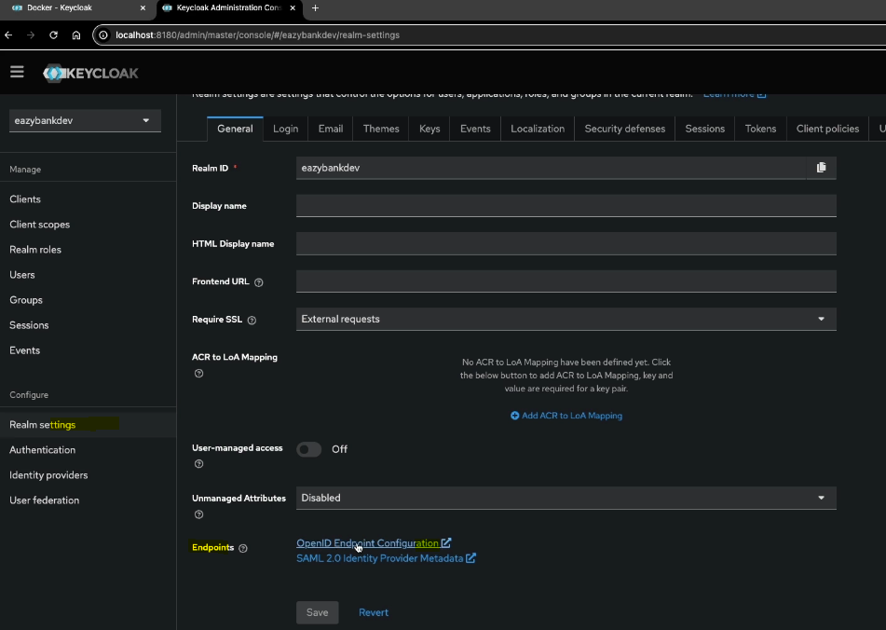

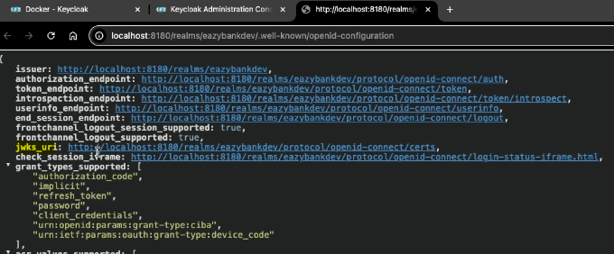

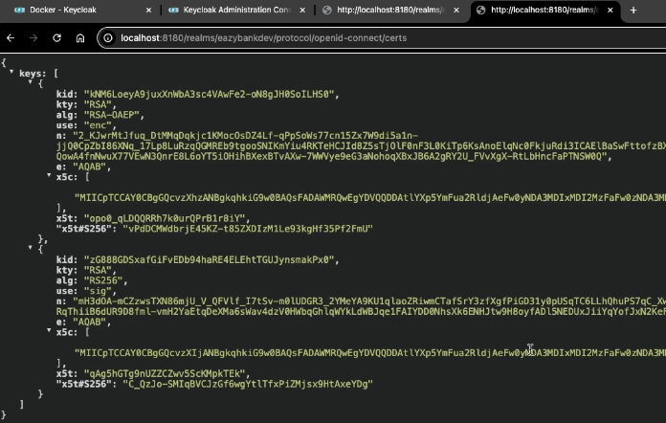

So using these keys, any resource server, they should be able to validate whether the given access token is valid or not.

Behind the scenes, like we discussed previously, what is going to happen is always the auth server, while it is trying to generate an access token, it is going to digitally sign it with an private key.

Whereas anyone who want to validate if the access token is valid or not, all such parties, they need to take this public key. Using these public keys only, the resource servers or any other applications, they should be able to validate if a given access token is valid or not. So that's the purpose of the certs URL.

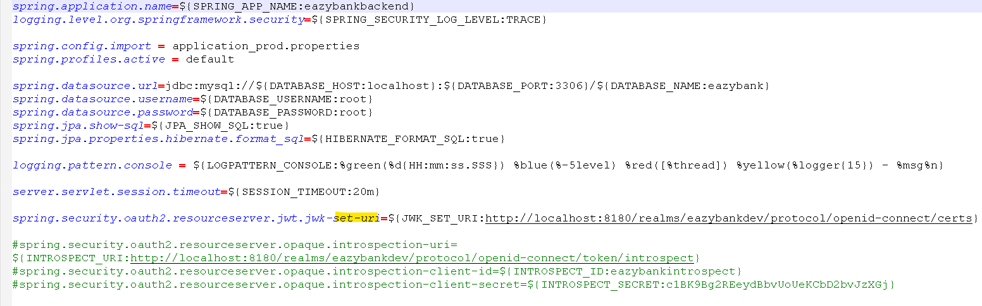

So the same we have configured here. So with this, what is going to happen is during the startup, my resource server, it is going to download these certificate details

or public key details from the auth server.

**With that, my resource server should be able to validate all the access tokens**

**without connecting to the auth server for each and every request.**

**Whereas, if we follow the opaque style of access tokens, then for each and every request, the resource server is going to make a call to the auth server.**

Anyone who's building an auth server by following the OAuth 2.0 and OpenID standards, they need to make sure they are exposing all the auth server-related information with the help of this URL.

For example, if we are looking for the details of the auth server that is built by the Google, we can simply open the URL like below.

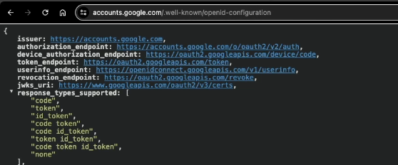

Client credentials grant type flow demo in eazybank

Think like this, postman as a third party application who want to invoke the secured APIs inside my resource server. With this understanding, let's try to test the ClientCredentialsGrantType flow.

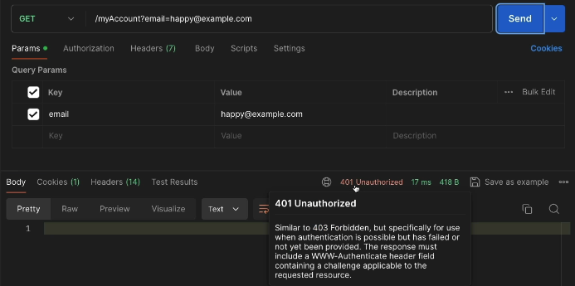

If you try to click on the send button, you'll be able to see we are getting post zero one unauthorized because we are invoking a secured API without any access token.

So to invoke this API successfully, first the client application, they need

to get the access token from the auth server or from the keyclock server.

The same access token, they need to pass to the resource server while they're trying

to invoke these get API. With the help of Postman, we should be able to test any OAuth grant type flows very easily.

So let's go to this authorization tab. Here, you need to select the option which is OAuth 2.0.

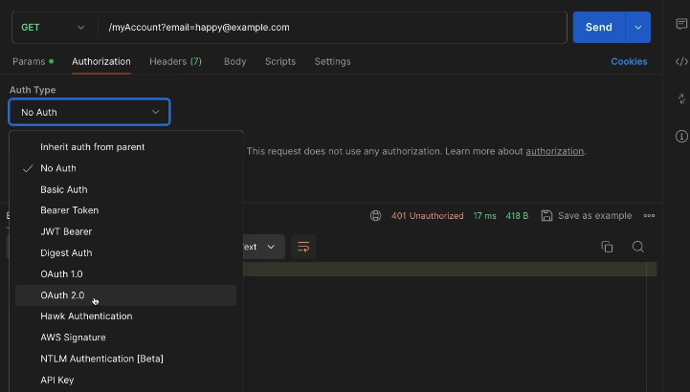

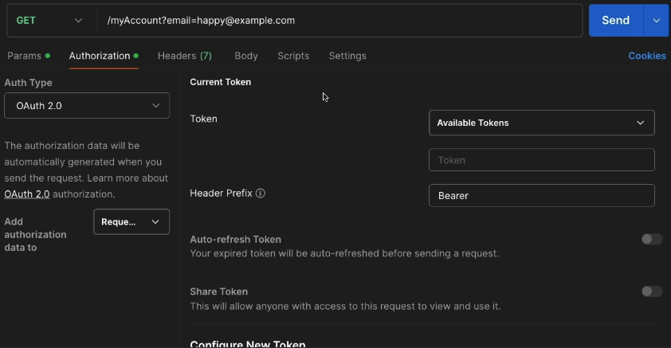 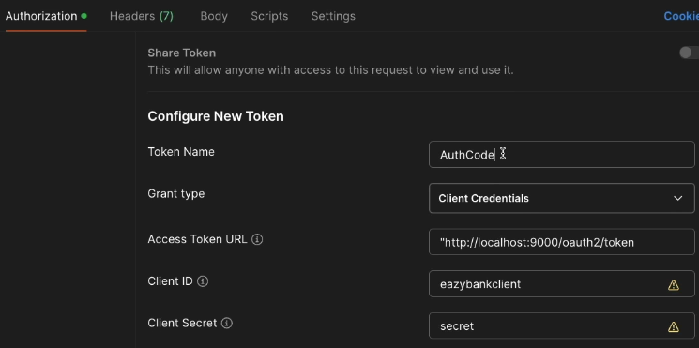

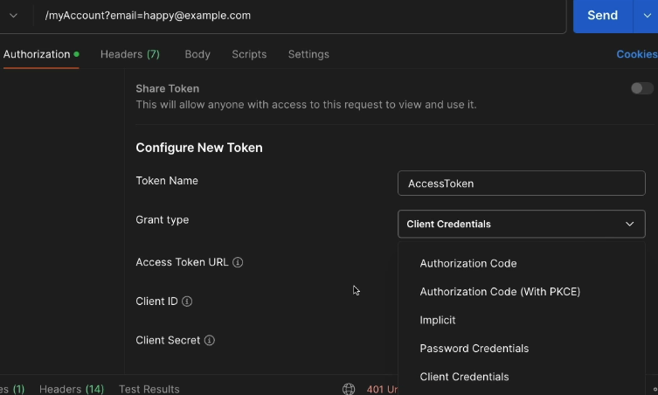 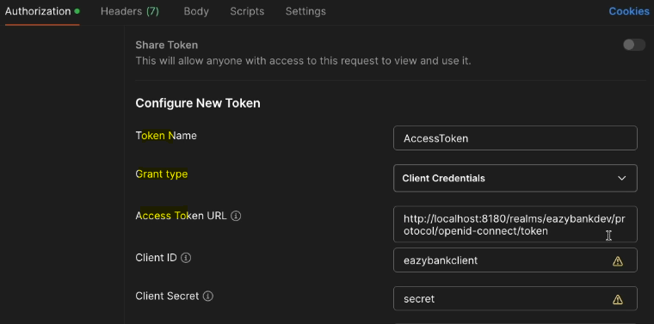

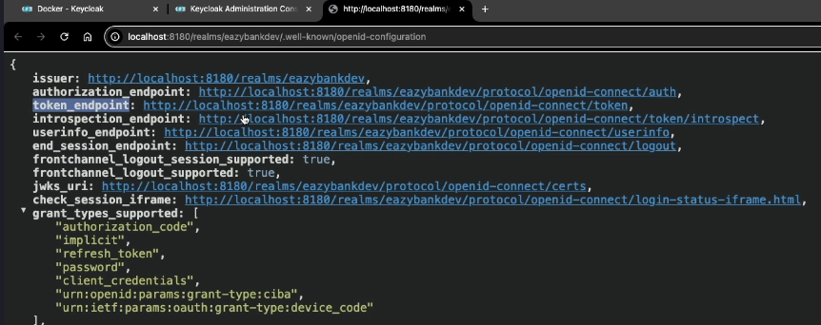 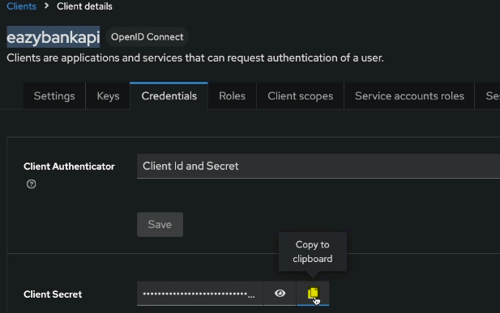

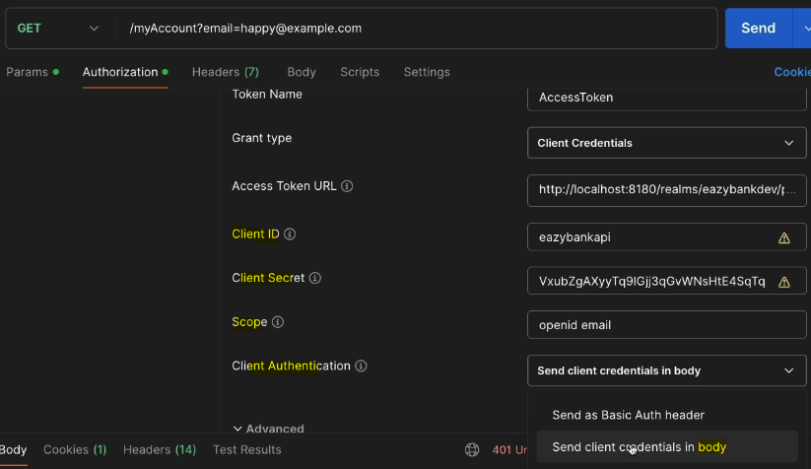 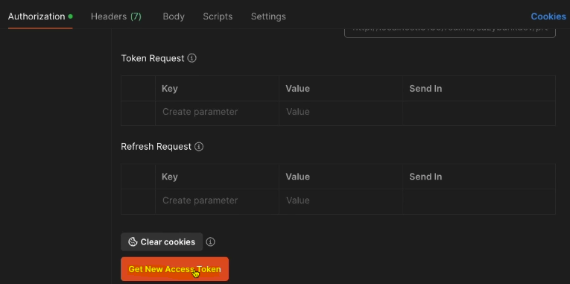

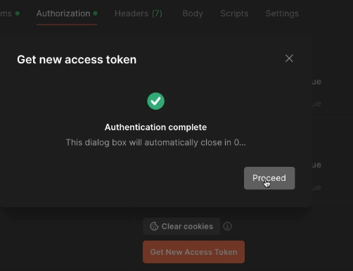 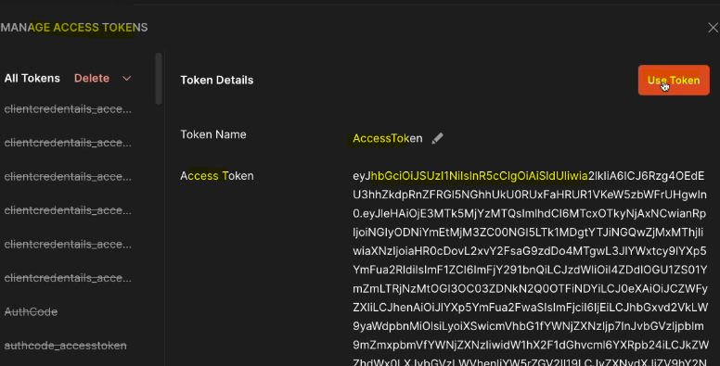

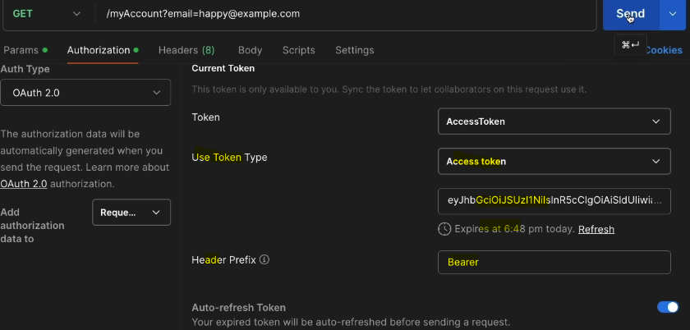 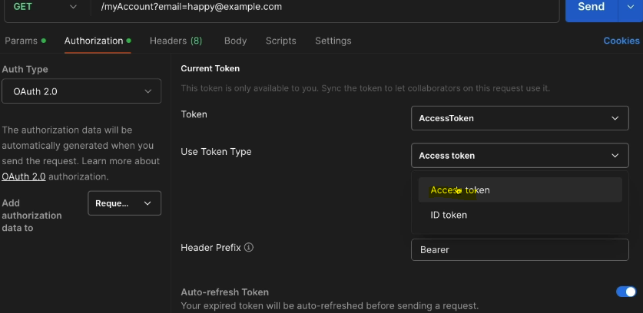

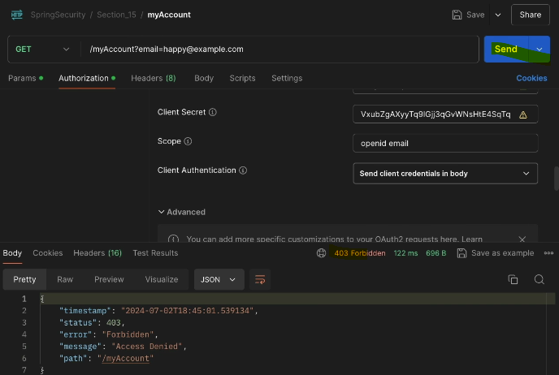

With this now we have populated the access token under the authorization.

If I try to click on the send button this time, you'll be able to see that I'm getting 403 Forbidden error. The reason why we are getting these 403 Forbidden error

is as of now, inside the ProjectSecurityConfig configurations this myAccount is configured for the user which has the role USER. Same for myBalance and myCards.

We enforce some authorization rules whereas for myLoans there is no authorization enforced. What I can do is, first I'll try to invoke the myLoans.

we have implemented the method level security for loans related API. If I go to the LoansController, you'll be able to see it is expecting a role user.

So to resolve this 403 error, what I have to do? For my client application, I have to configure roles inside the keyclock server.

So here first I'll go to the Realm roles and click on these Create roles

and I'm going to create a couple of roles.

Configure role in keycloak server:

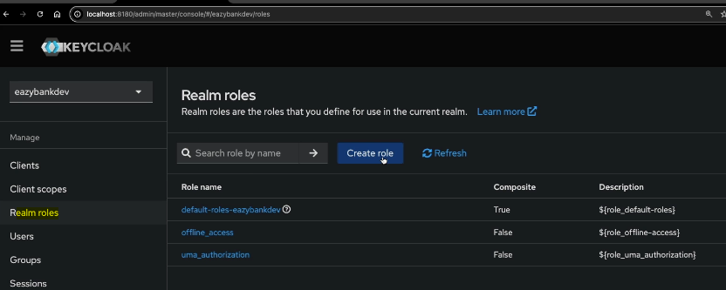 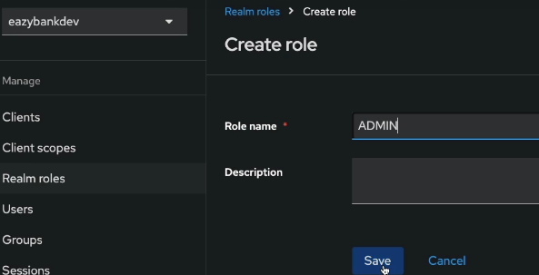

So since this is a client application, we should not configure the roles.

Instead we should configure the service accounts roles. So the roles concept is only for the end users, whereas for the client applications we need to use these service account roles.

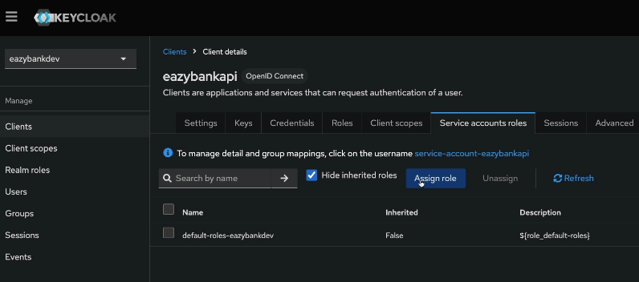 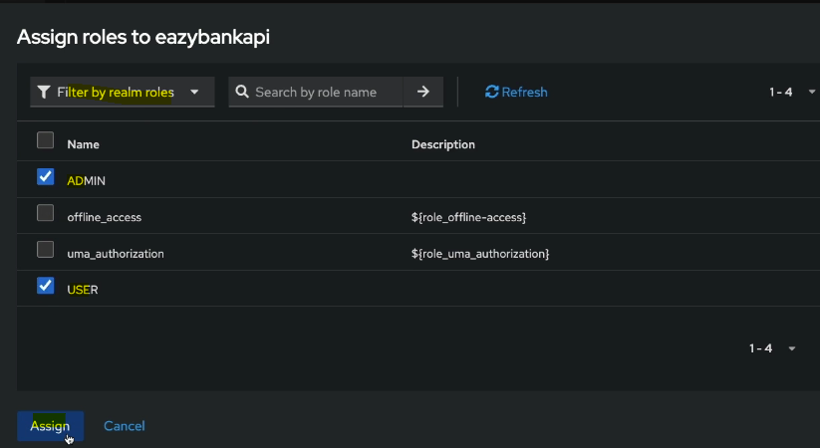

With this new role configuration, get new access token in post man and view in jwt.io

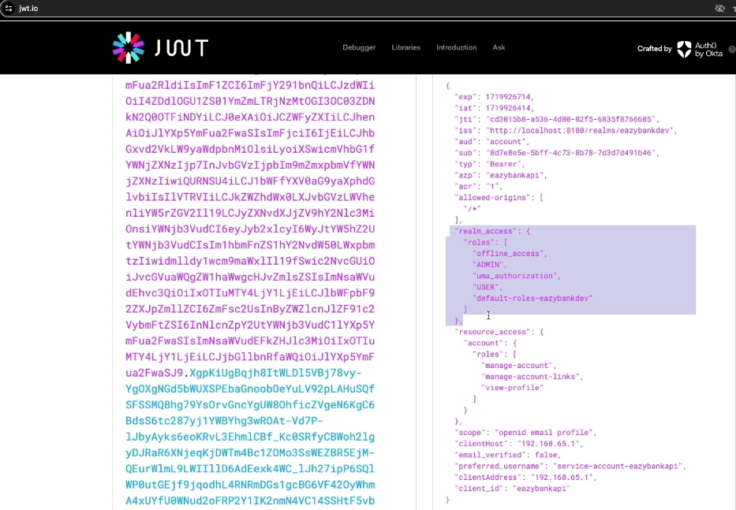

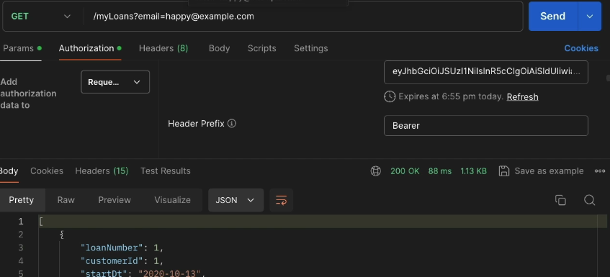

Demo of Opaque Tokens - Part 1

As of now, inside the resource server, we have made these configurations.

So here we are invoking the jwt method in config class. With this method,

we are trying to tell to the resource server, saying that my auth server is going

to issue the jwt tokens, and these tokens can be validated locally with the help of the certificates downloaded from these jwk-set-uri.

With this setup right now, the resource server, it is trying to validate the access tokens locally without having any dependency on the auth server.

Only during the startup of the resource server, it'll try to connect to the auth server

to download the certificate from this URI.

I can also show you the demo very quickly. So here first I'll try to get a new access token. Obviously, when we are trying to get an access token, we are going to have the dependency on the auth server. So, this access token is going to expire at 8:05 PM, right now, the time in my system is 8:00 PM, so by default, the access token lifespan is going to be **five** minutes.

So now before I try to click on the send button, what I'll do is I'll try to stop the auth server.

So, inside my Docker Desktop containers, so this is the key clock container,

I will try to click on this stop button. So don't try to delete the container.

With that, you need to create the client details as well from scratch.

So now my auth server stop. If I click on the send button by passing the access token that we fetched previously, you will see a successful response.

But unfortunately, I'm getting a 500 error because when we are trying to send the very first request to the resource server, it is trying to download the certificates.

So previously I was telling that the certificate is going

to be downloaded during the startup, but seems the certificate is being downloaded

during the very first request.

Stop keycloak server in docker and try to get access token

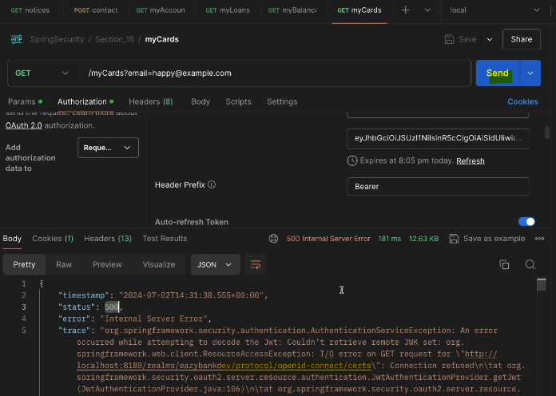

As a next step, I will show you how to set up the opaque tokens format

inside the resource server so that the resource server can validate the token for each and every request.

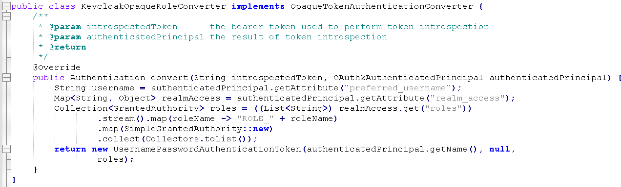

The very first parameter to this method indicates introspected token.

So this is the same token that my client application sent to the resource server.

The same token behind the scenes, my resource server will validate with the auth server by invoking an **introspected** **URI**.

So once the introspection is completed, this method is going to be invoked

again with the introspectedToken along with the OAuth2AuthenticatedPrinciple,

you can also see the method input parameters description, introspectedToken means the bearer token used to perform the token introspection,

whereas authenticatedPrinciple is a result of token introspection.

So during the token introspection, what is going to happen is the resource server is going to give the token received from the client application to the auth server, the auth server, in turn, it is going to validate the introspected token and give more details about the end user, like his username, his roles, all such details we are going to get in the form of this object, which is OAuth2AuthenticatedPrinciple.

Demo of Opaque Tokens - Part 2

Mention introspection-client-id, introspection-client-secret and introspection-uri.

So we need to give details to the resource server, which endpoint URL that my resource server has to call on the auth server whenever it want to validate a given opaque token or a given access token.

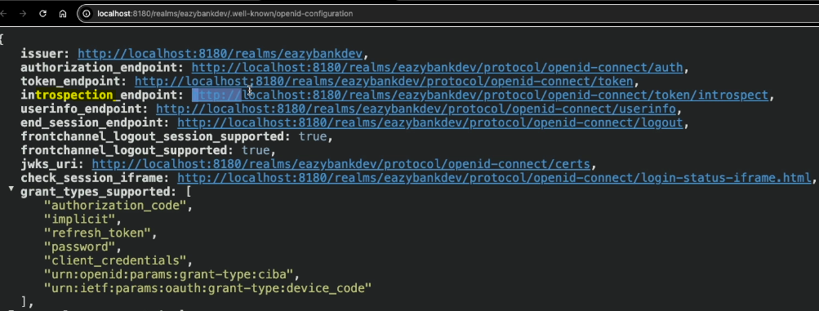

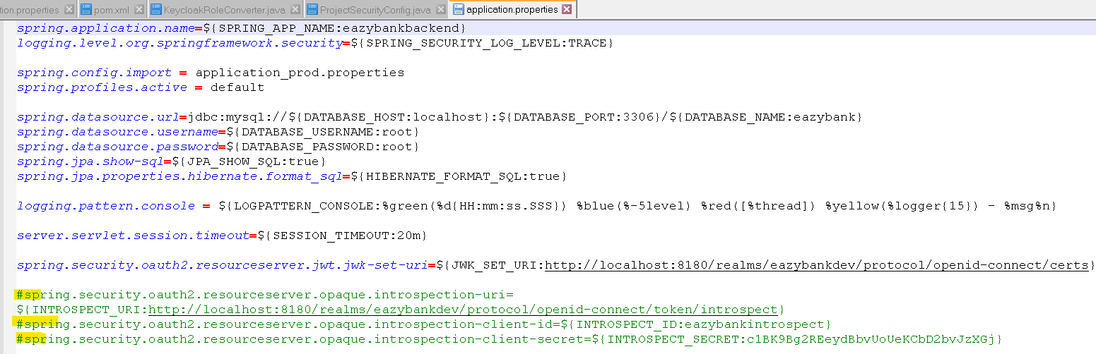

My auth server is not going to simply accept any traffic from unknown servers or from unknown resource servers. So the resource servers, they should have registered with the auth server and get a client ID and client secret the same

they have to use whenever they're invoking these introspective URI.

So that's why inside my admin console, I'm going to create a new client details in keycloak server.

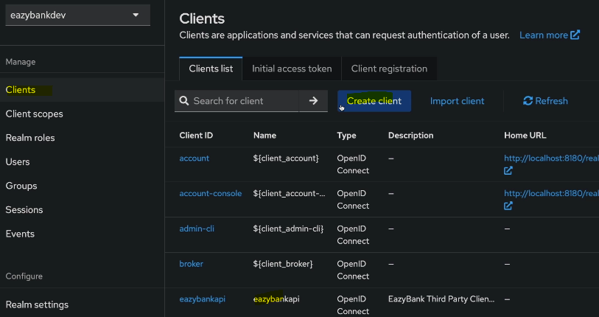 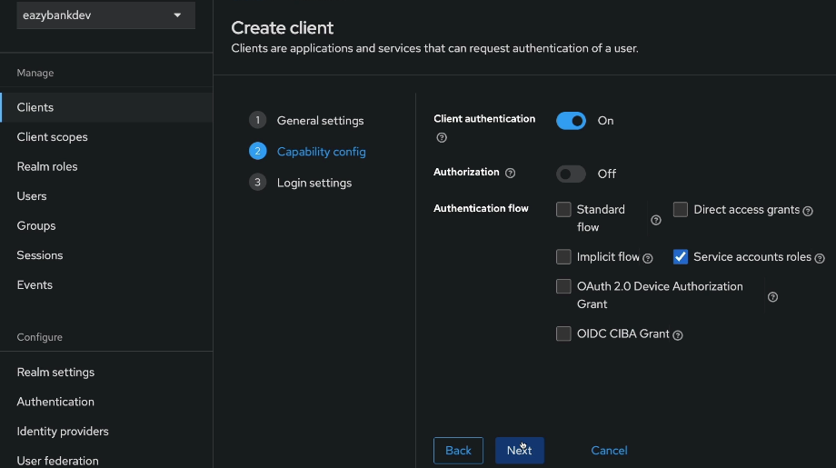

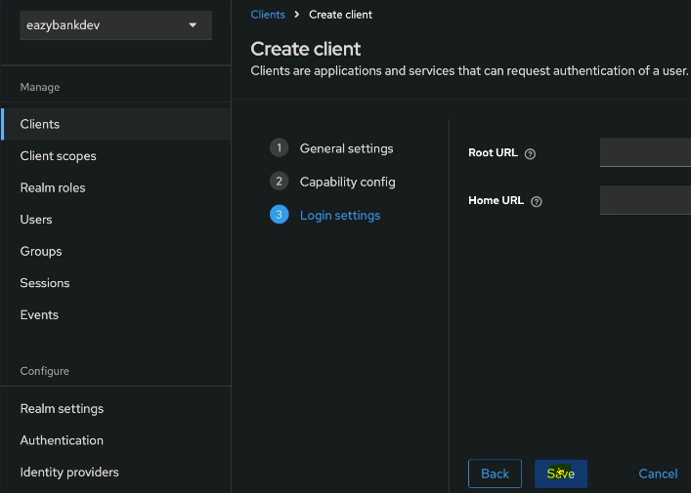 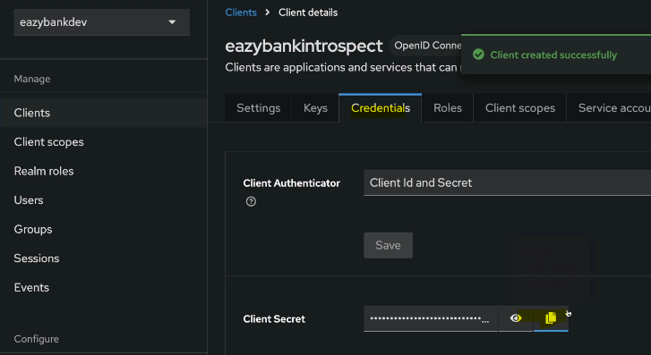

The same secret I'm going to paste in application properties in above. So this is the client secret, followed by client ID eazybankintrospect. So with this, we have created three different properties that my resource server can use during the token introspection.

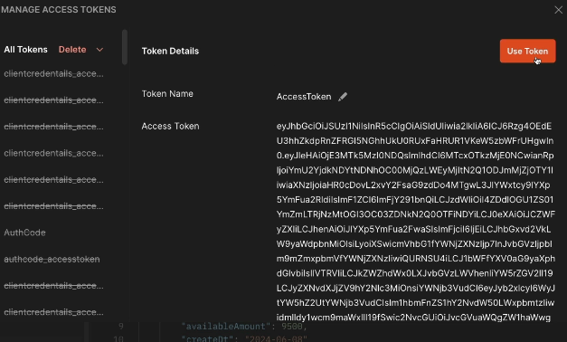

Inside my Postman, first let me get the new access token from the auth server. So if I click on this get new access token, I'm going to get an access token. And here the access token still in the JWT format. Unfortunately, we can't change the format

of these access token from JWT to opaque because as of today, while I'm recording this session, keycloak does not support issuing the tokens in the opaque format.

Always, it's going to issue the tokens in a JWT format only.

Regardless of what is the format of token, it is going to issue my resource server

always it's going to validate the token for each request because we have configured the opaque token related configurations. In the coming sections when I'm showing you the demo of auth server with the help of spring auth server project,

I'll show you how the opaque token is going to look like, because the auth server built

by the spring auth server project, it is going to support issuing the opaque tokens.

Let me use these token and click on the send button and you'll be able to see I'm getting a successful response.

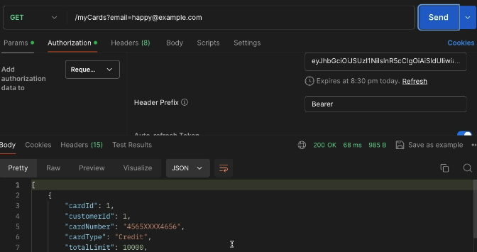

Now what I'll do is I'll stop my keycloak container. Once a keycloak container is stopped, This time If I click on the send button, you can see I'm getting a 500 error.

If you try to understand the details of the error, you will see the exception saying that

IO error on POST request for localhost:8180/realms/eazybankdev

protocol openID connect/token/introspect.

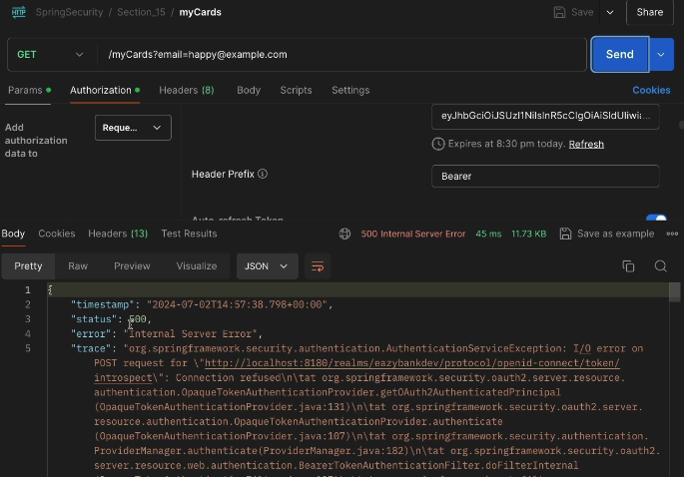

So the connection is refused. That's why the token validation failed

and the client applications are going to receive the 500 error.

This confirms to us that whenever we configure opaque tokens inside our resource server then for each and every request, the token is going to be validated

by the resource server with the auth server. So this approach only recommended for critical applications.

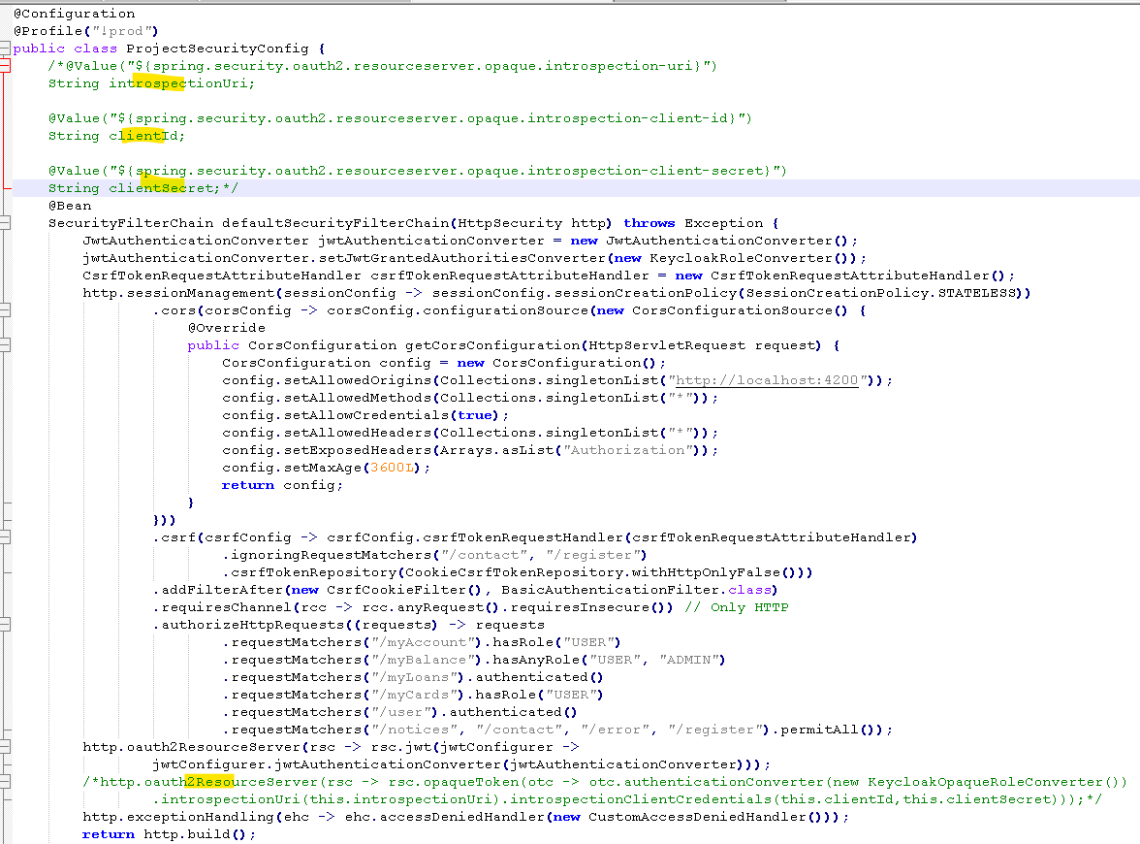

Creating Client and User details inside KeyCloak for Auth code grant flow

As of now we saw the demo of Client Credentials Grant Type flow. As a next step, let's try to see the demo of Authorization Code Grant Type flow.

We need to use the Authorization Code Grant Type flow whenever an end user is involved. So there'll be an end user and there'll be a client application,

which is usually an UI application where the end user is trying to access

a secure resource from the resource server.

So this client application, it is going to ask the end user to enter his credentials in the auth server login page. Once the end user identity is completed, the client application it is going to work with the auth server to get an access token.

So as of now, under my EazyBank dev realm, I have only a single client

with the name Eazy Bank API. I can't use these client for my Authorization Code Grant Type flow because this client, it only supports Client Credentials

Grant Type flow, but not the Authorization Code Grant Type flow.

So for the Authorization Code Grant Type flow I need to create one more client.

So let me go to these client and click on these create client.

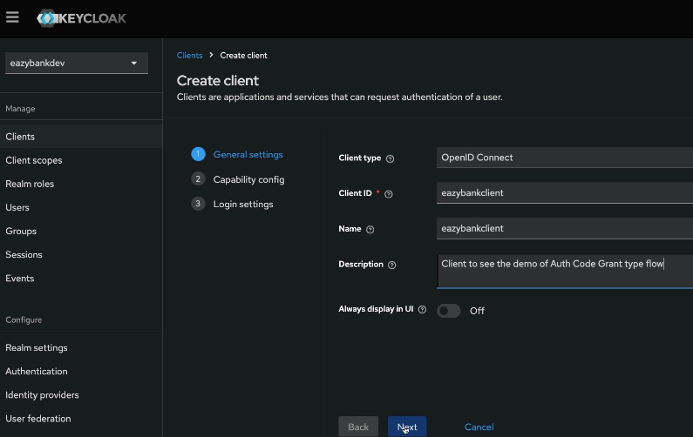

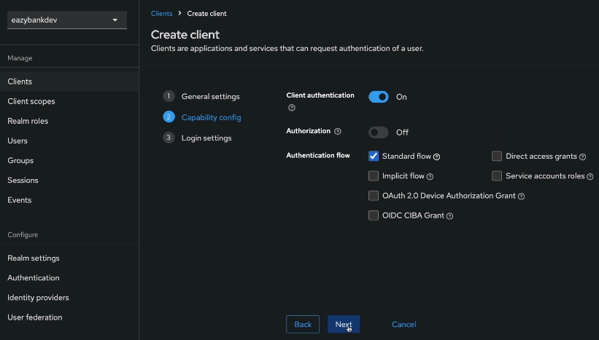

I'm enabling these client authentication.

So as of now, I'm assuming that my client application, they are capable of storing the client to credentials. So standard flow means Authorization Code flow.

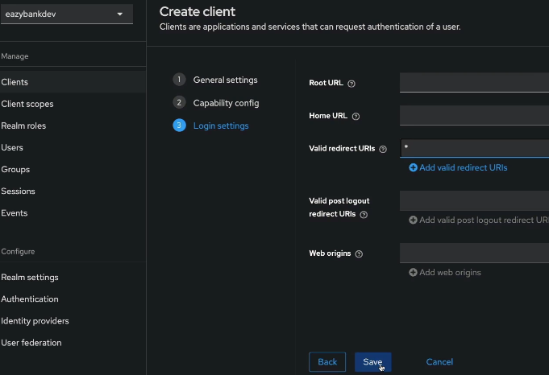

The valid redirect URLs for now, I'm going to mention asterisk.

That means I'm fine with any page where my auth server is going to redirect the end user after the authentication is complete.

But in real production application, you need to mention a proper URL of your application so that the end user is going to be landed onto these redirect URL

once authentication is completed.

Since we're going to explore the Authorization Code Grant Type flow

with the help of Postman, we need to make sure we are mentioning these asterisk mark.

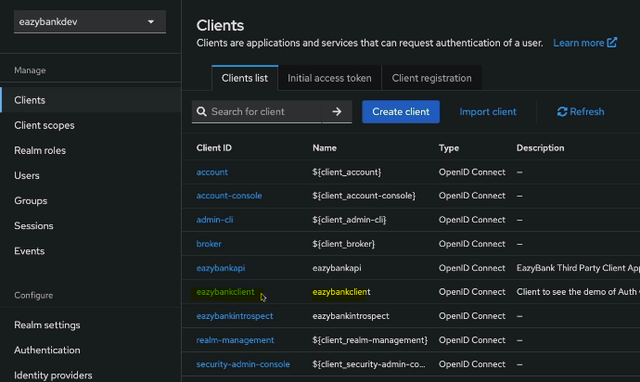

So next, I'm going to click on this save button followed by, I'm going to click on these credentials where we can see the client to secret for this client.

As of now, I just registered a client with the auth server. So this client with the name Eazy Bank client it is representing a client application that is capable of handling

Authorization Code Grant Type flow.

**As a next step, we should also create an end user details inside my keycloak auth server. Because we know inside Authorization Code Grant Type flow,**

**end user is also going to be present where the end user has to enter his or her credentials.**

**So to create the end user, I need to click on this user.**

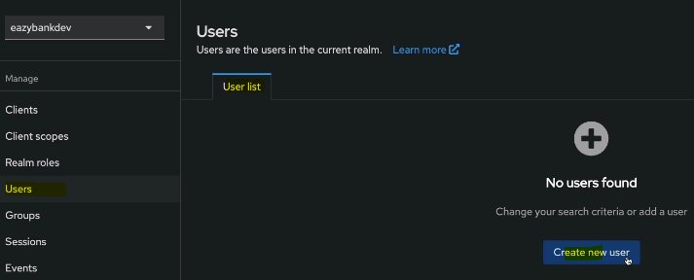

So here I'm going to create the end user manually from my admin console by clicking on this new create user. But in real applications, the keycloak, that means they are never going to create the users manually one by one.

We should also give flexibility to the end user to register himself from the website.

So for such scenarios, we can't use this manual approach.

Instead we are going to use the rest APIs approach. So whatever action that I can perform on my admin UI, the same actions we can also perform with the help of REST APIs.

If you go to the keycloak website and click on these docs, you have details around the administration REST API. inside this page you'll be able to see all the rest APIs

that are supported by the keycloak server.

So anytime if you want to programmatically create an user from your UI application

or from your backend code, you just have to come to this page and look for the API that is going to help you to create a brand new user.

So under the users, you'll be able to see there are so many APIs which are going to help you around the functionality of user creation, user retrieval, user updates.

Similarly, there are many other REST APIs supported by the keycloak.

That's why don't be under the assumption that always we need to perform the configurations manually. We also have REST API approach, where the client applications and backend applications can leverage to perform all the administration related tasks.

For now, let's try to create the user manually.

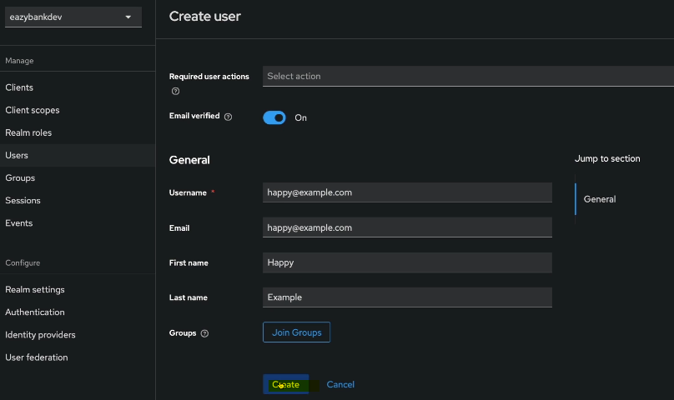 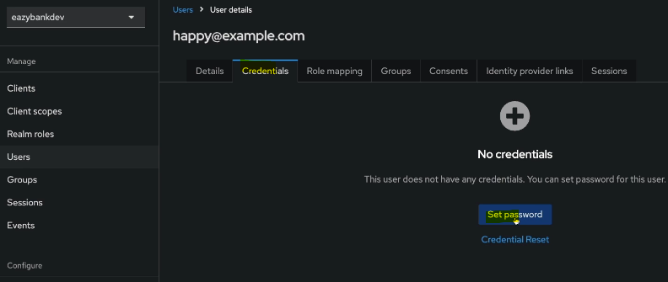 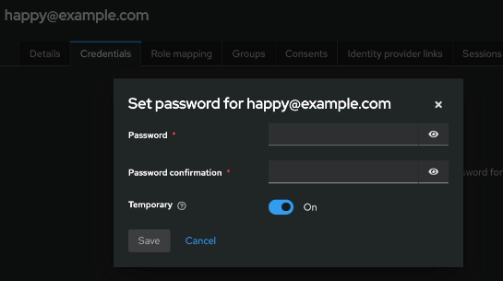

With the default configurations, keycloak is going to accept any kind of passwords,

but the real enterprise applications, they should not accept the end user's passwords

with the simple combinations So to stop the end user from using or creating a simple passwords, we can make some configurations inside the keycloak.

So under these realm, which is eazybankdev, you need to click on this authentication.

Inside this authentication page, you can click on this policies and here you can define various policies based upon your business requirements.

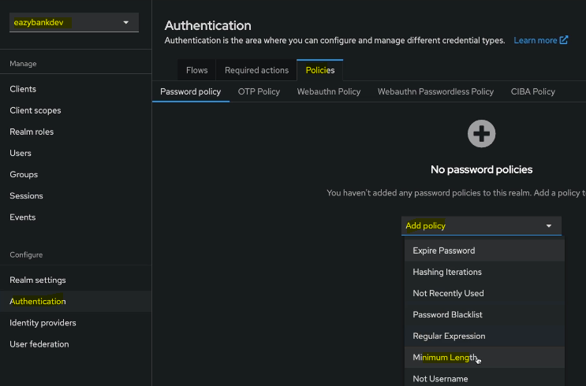

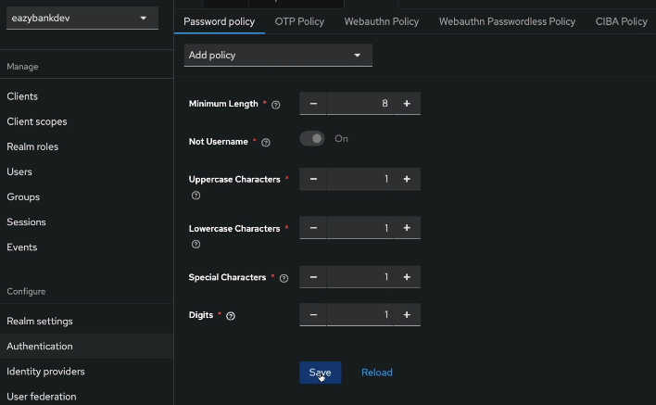

Set password now using the policy

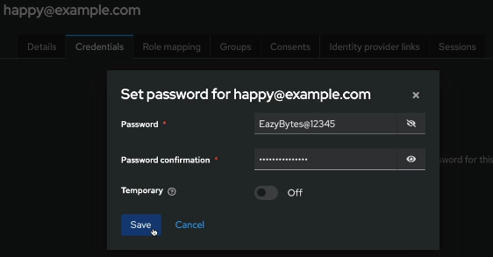

I'm going to disable this temporary. So this gives a confirmation to my keycloak

that this is a permanent password. If the temporary option is enabled, then during the very first login of the end user, the keycloak is going to ask to change the password.

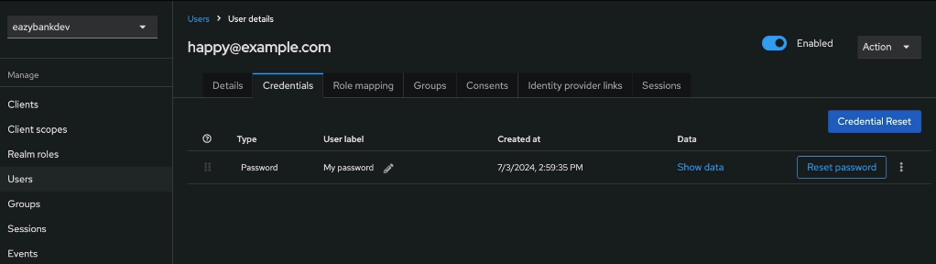

With this, we have successfully registered client application details inside the keycloak. Along with that, we also created an end user So as an next step, we should be able to see the demo of AuthorizationCodeGrantType flow.

Testing Authorization code & refresh grant types using Postman App

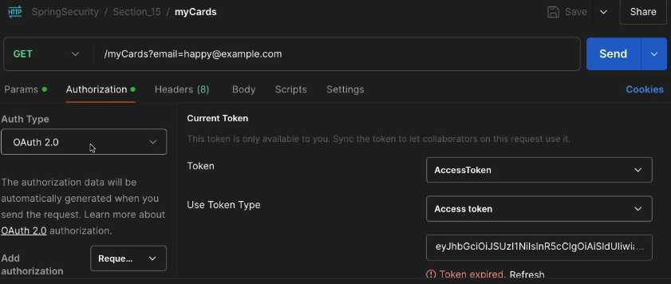 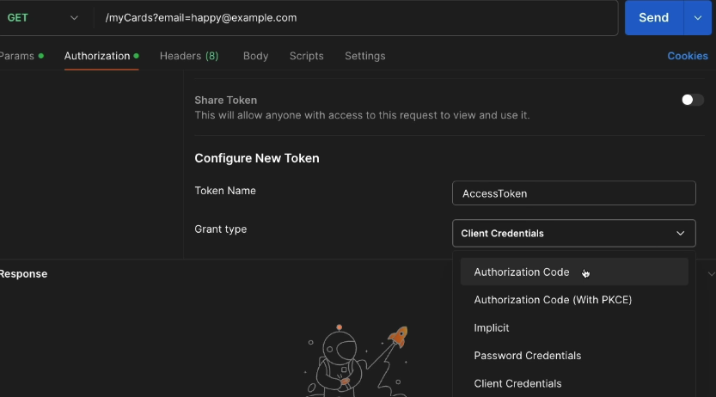

Once we select this authorization code, we need to make sure we have selected this checkbox which is authorized using browser. With this checkbox, what is going to happen is whenever we're trying to get an access token with this grant flow, the Postman is going to leverage the browser to ask the end user credentials.

Once the end user authentication is successful, this is the URL where the Auth server is going to redirect back to the Postman.

If you can recall previously when we were trying to create the client inside the keycloak, we have made those configuration just to support these functionality provided by the postman.

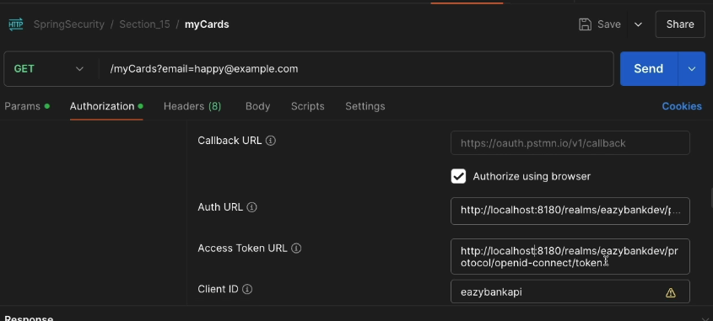

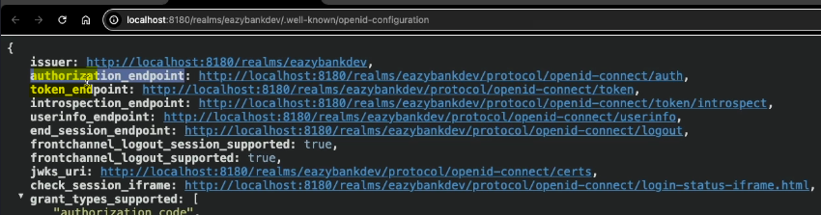

Now coming to the Auth URL, you can get this URL from the well-known Open ID

configurations URL. So here we have authorization endpoint.

Access token, URL, is available inside this page with the name Token_endpoint.

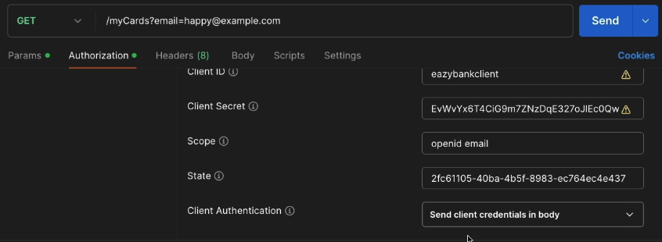

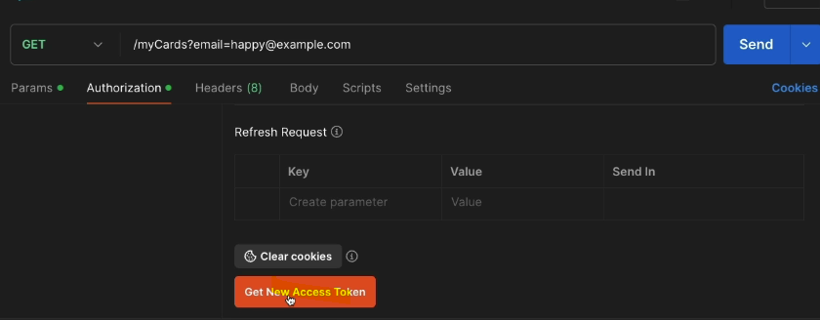 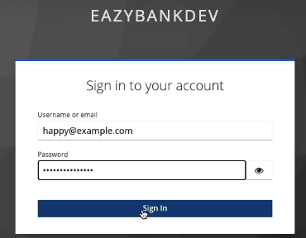

So now if I try to click on these get new access token I will be taken to your browser

where Keycloak login page is going to be displayed. So before you try to click on this button, please make sure all of your browsers are closed. So as soon as I click on this get new access token, you'll be able to see I am redirected to the login page of the Keycloak.

So here this is my real name and I can enter the username or email, which is [happy@example.com](mailto:happy@example.com). Next, the password I'm going to enter,

which is eazybytes@12345. So as soon as I press sign in, I will be redirected

to the postman.

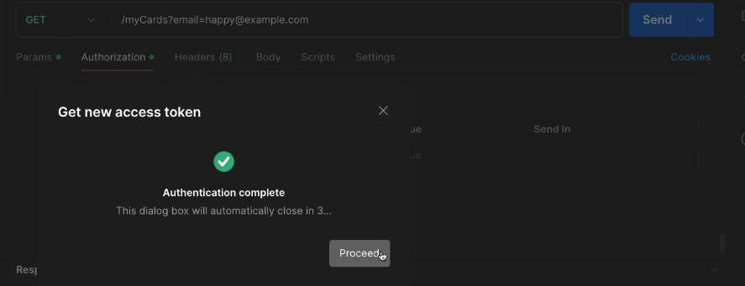

And here I need to click on this proceed, which is going to give me the access token.

Along with the access token, we're also going to have refresh token, ID token.

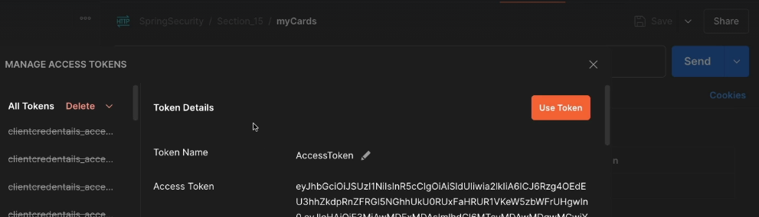

So all these details you are going to have under these window.

But now let me use the access token inside my rest API invocation.

So if I try to click on the send button, you can expect a 403 error.

It's very obvious because the end user happy@example example that we have created in the previous lecture, you don't have any roles configured which are required by my resource server. That's why it is throwing 403 error.

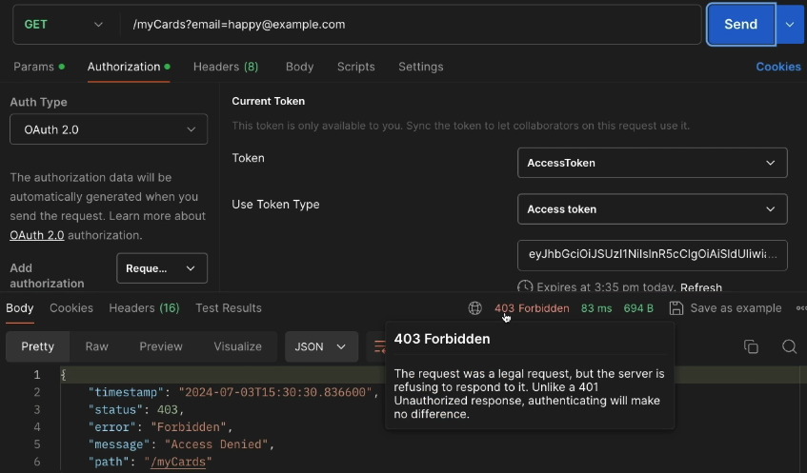

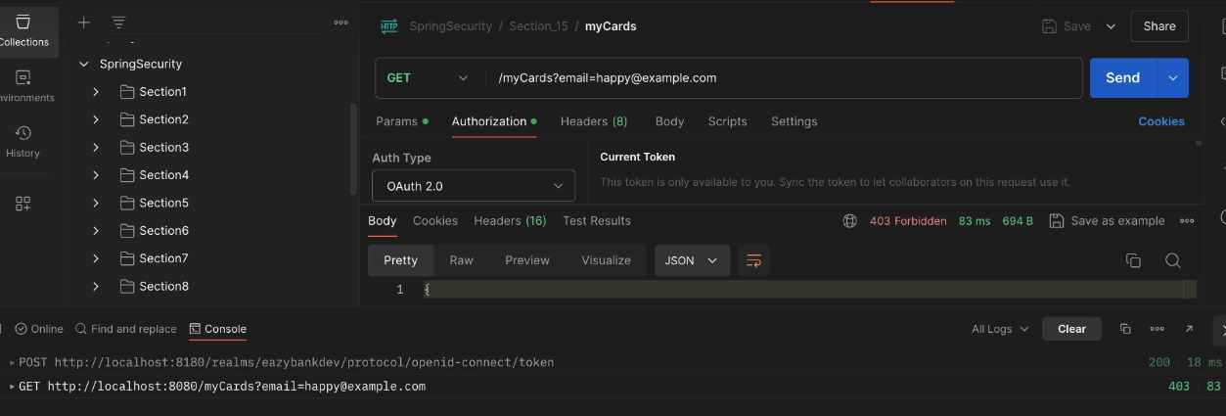

Here, you can try to understand there is a post request triggered by my postman once the user authentication is completed. So inside this post request it send

that details like authorization code grant_type as authorization code redirect_uri,

client_id, client_secret. So all these details it sent to the auth server

to get an access token.

Once the access token is received, the actual API is invoked by the postman.

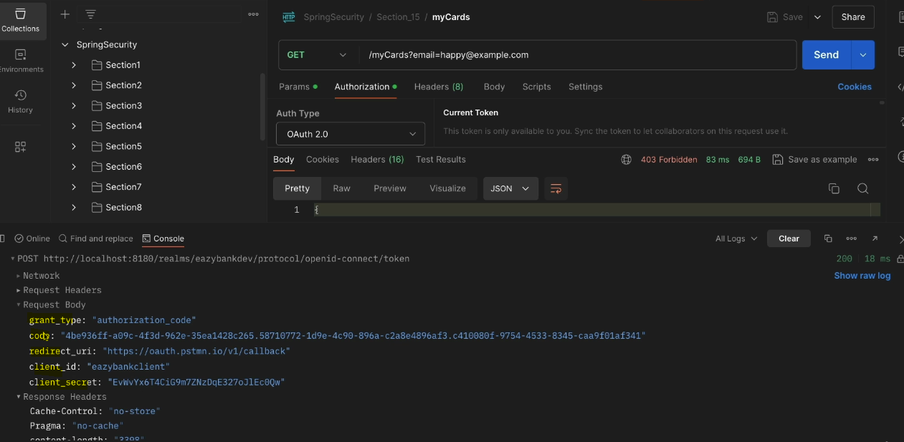

To resolve this 403 error, we need to add roles to the end user.

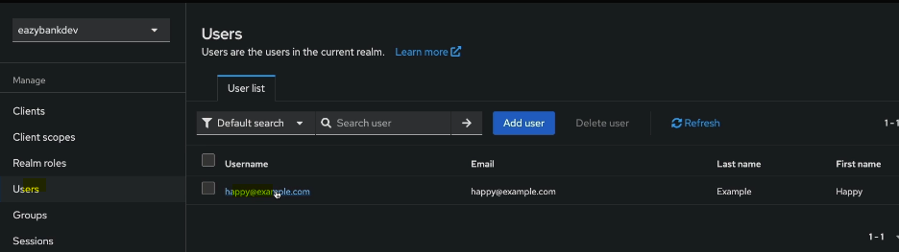

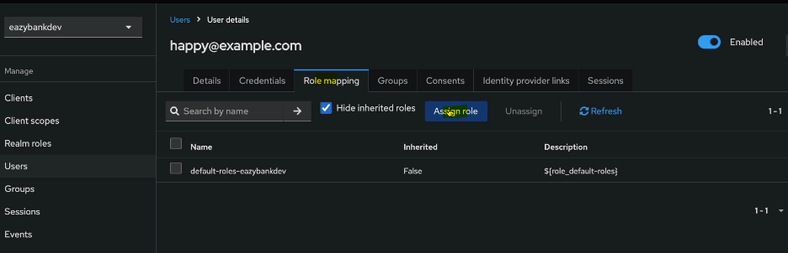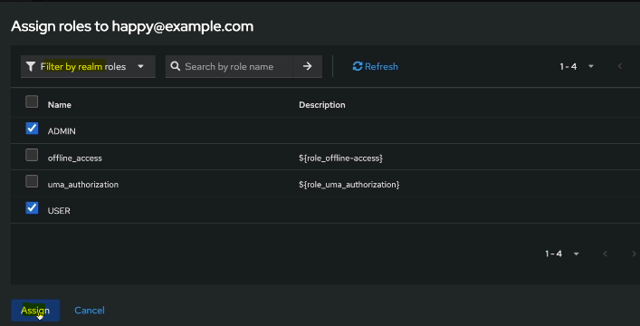

So once we make these changes, the access token should have these details.

Let me get a new access token by clicking on these get new access token.

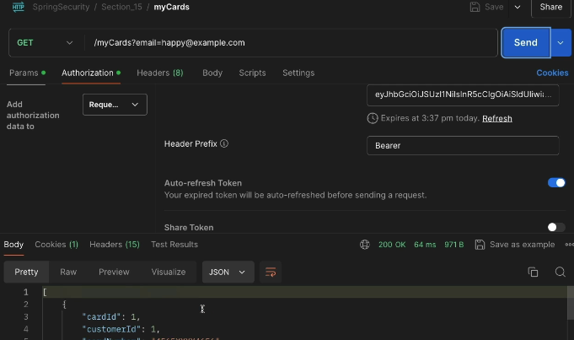

Let me use this token and click on this send button this time.

Hooray we are getting successful response. As of now, you can see the token is going to expired after five minutes, which is 3:37 PM.

So right now the time is 3:33 PM inside my system.

Like I said before, by default, like I explained previously, the access token lifetime is five minutes. We can change these if needed.

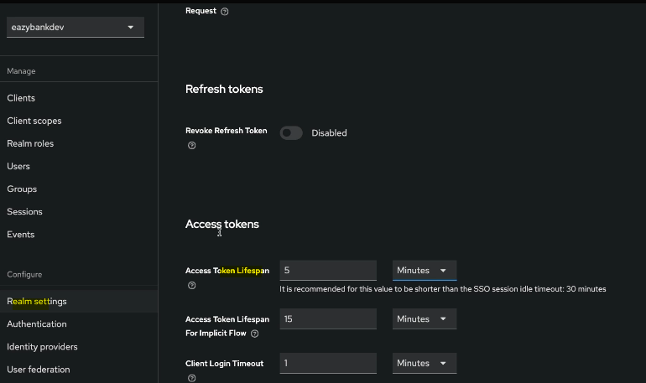

the Refresh Grant Type Flow:

We also discussed about the Refresh Grant Type Flow in case if your token is expired, you don't have to get a new access token.

Instead you can leverage the Refresh Grant Type flow to get the access token.

How to trigger the refresh grant flow inside Postman. It's very easy.

You need to click on these refresh hyperlink.

And with that behind the scenes postman is going to make a request to the auth server to get a new access token by providing the refresh token

as an input.

I'm going to show you the demo of refresh grant flow very quickly.

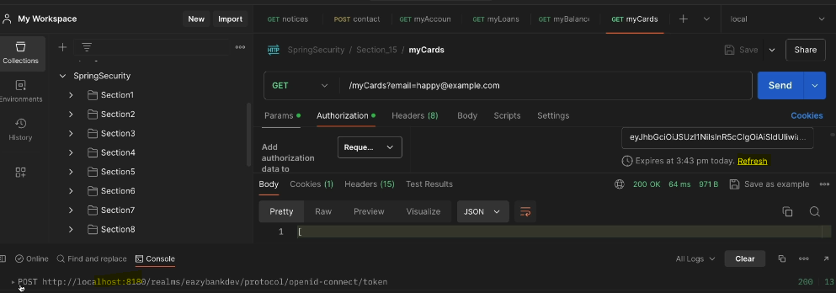

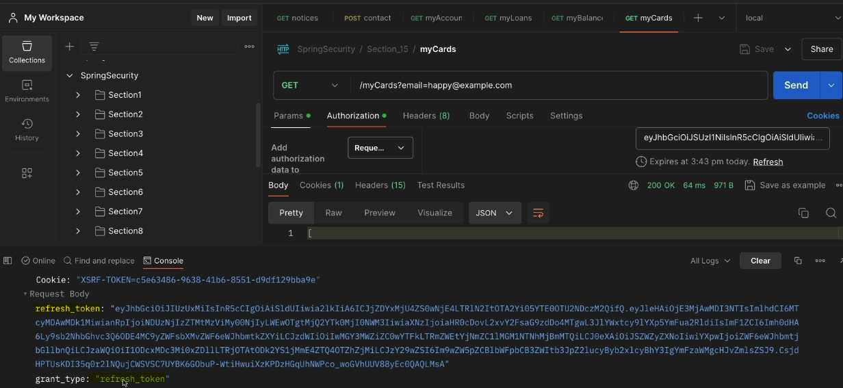

So if I click on this refresh, you can see I got a new token, but if I go

and check the console, what happened behind the scenes, my postman made a post request to this URL to get a new access token.

This time if you try to see what is there inside the RequestBody, you'll be able

to see there is a refresh_token along with the grant_type as refresh token

and as a response, we received a new access token.

The same is populated by my postman inside this field.

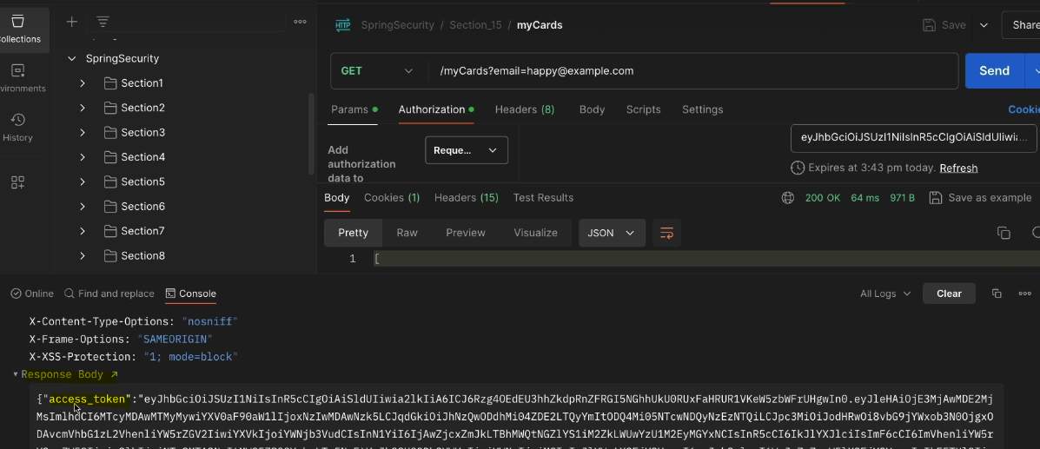

Login page and theme design:

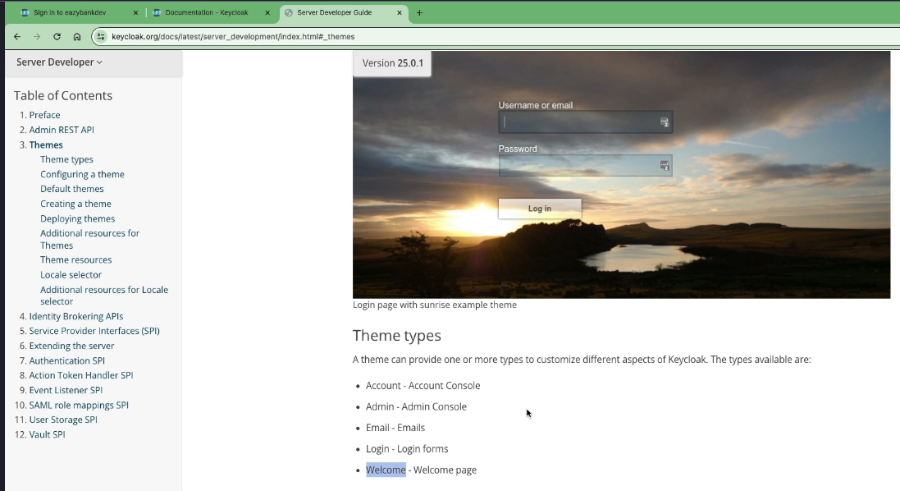

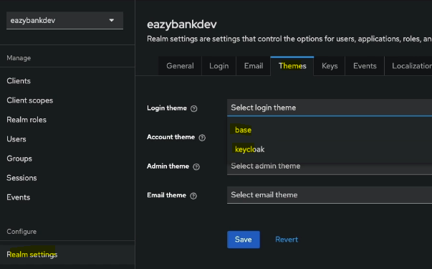

These are the default themes provided by the Keycloak.

Once you create your own theme and paste it inside the Keycloak themes folder,

you'll be able to see your own theme option here. Once you've selected your own theme, obviously the end user is going to see whatever theme

that you have configured.